GRM Poverty Reduction White Paper #3 October 2018
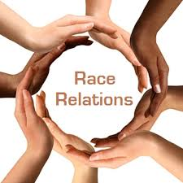 | Abstract  The issues of hunger, education, family, racial inequality, social inequality – these must be viewed through the eyes of the lack of affordable housing.

Racism as a Cause of Poverty
The Economics of Racism

White Paper
on
Racism as a Cause of Poverty
Jack Murr
Director of Rescue
The Gospel Rescue Mission, Inc.

In this white paper, we will educate ourselves on the effects of racism and racial discrimination on the economic welfare of minorities; particularly how racism has caused and continues to cause economic hardship on the African American community.
NOTE: While in this paper we are exploring the effects of racism and racial discrimination in relation to the African American Community many of the solutions and insights might apply to other non white communities that have experienced discrimination and oppression. We will examine the details of those other cultures in future white papers.
This topic in particular has the power to offend. The authors ask that you judge any flaw or offense as a failure of the mind and not the heart.

In this current time of history some might argue that we are living in a post racism climate. They would point out the fact that we have now had an African American president so obviously we have overcome this issue. So the question we begin with is, do we have a problem with race relations in this country?
Let us begin our exploration with a quick look at how a majority of African Americans came to the shores of the United States in the first place.
One source establishes the following: “Slavery in America started in 1619, when a Dutch ship brought 20 African slaves ashore in the British colony of Jamestown, Virginia.” (https://www.history.com/topics/black-history/slavery).
From 1619 until 1860 the United States slave population grew from those 20 to nearly 4 million, and by 1860 slaves represented 53% of the southern population in the United States.
It is no secret then that slavery in America was considered to be a purely economic activity by those who relied on slave labor. The spiritual, psychological, emotional, cultural, financial and physical impact on the slaves themselves was nearly a non-issue unless addressing such issues was beneficial to the slave owner.
In all of the areas that we are exploring as possible causes of poverty in America it is important to always look to see who is profiting from those in poverty.
The methods used to convert a man or woman from a thriving culture into a slave were scientific. Dignity and identity were stolen first and then honor and hope were destroyed so that these men and women could be controlled. What would be the result to any culture that had developed proud histories of wealth, warriors and wisdom?
The Slave Era
An honest reading of history makes it obvious white slave owners considered the slave to be sub-human property. One problem with that observation of white slave owners, and the white culture surrounding American slavery is the effect that slavery had on the black family.. Consider this excerpt from an article “8 Ways Slavery Affected Black Families And Still Has An Impact Today” by Yanique Dawkins in the Atlanta Black Star, October 13th, 2014.
Here is the list:
“8 Ways Slavery Affected Black Families and Still Has an Impact Today”
- Illiteracy – Schooling was not an option and it was illegal in most states to teach a slave to read and write.
- Unpaid Workforce – The use of unpaid labor to produce wealth and profit for slave owners. Meanwhile the slaves often worked from dawn to dusk with few rest periods.
- Broken Legacy – Enslaved families were a part of a slave owner’s inheritance and families were often separated when a slave owner died.
- Mortality Rate – More than one-half of black infants died before they were 1 year old. This mortality rate was almost double that of whites.
- Broken Traditions – African family traditions, which varied according to national origin and religion, could not be replicated in the New World after Africans were forced into slavery. Husbands, wives and children could be sold separately because the U.S. did not legally recognize families.
- Broken Families - Enslaved Black people were denied a secure family life. Because they were property and could not legally marry, a permanent family could not be a guaranteed part of enslaved people’s lives. They had no right to live or stay together, no right to their own children, and it was common for enslaved parents and children to live apart.
- Soldiers’ Lives - During the Civil War, approximately 180,000 Black soldiers served in the Union army. The families of these soldiers frequently camped in makeshift villages near the army to be near their husbands, sons and fathers. The soldiers assisted them as they could — sharing food and clothing from their own military rations when possible.
- Rape of Women - Slave women were constantly sexually abused by white men, and they had no legal right to resist that abuse. To oppose the rape of Black women in effect meant opposing slavery. A Black woman’s body was not considered her own. Control over her body was passed from white person to white person along with a bill of sale.
(“8 Ways Slavery Affected Black Families And Still Has An Impact Today” By Yanique Dawkins - October 13, 2014).
Over 400years an entire race of people were sacrificed to the gods of wealth. Consider what would happen if any race of people is traumatized by the effects of a life of slavery for that long how long does it take for the effects to diminish and become inconsequential?
With the close of the Civil War the African slaves were set free from their daily lives of bondage. But what next? What do you do with millions of suddenly free men and women? Fear must have struck the heart of every former slave owner. Consider the feelings from the book of Genesis of the brothers that had sold Joseph into slavery. They were convinced that Joseph was just waiting for his opportunity to get his revenge. Yet, Joseph bypassed the opportunity to enact vengeance.

Genesis 50:20 English Standard Version (ESV)
As for you, you meant evil against me, but God meant it for good, to bring it about that many people^{[a]} should be kept alive, as they are today.

In a similar way the white men and women were filled with fear and though there are very few recorded incidents of these newly freed people taking their vengeance, the fear became overwhelming for the white population and they quickly began enacting laws to keep control of the African American population. These series of laws went by many names but found their most pressing version in what were called Jim Crow laws. These stiff discriminatory laws and practices kept African Americans “in their place.”
NOTE: While the term “Jim Crow” laws typically focuses on those in the south it should be noted that similar laws and discrimination were in effect in the northern states as well.
On white man’s memory:
I can remember going to segregated church camp in the 1960’s. There was Negro camp week and there were several “white weeks” at which school-age children could attend summer church camp.
In Eastern Kentucky where I grew up, I remember the county I lived in had a small population of African Americans, 100 or so, that were “allowed” to live on the side of a mountain. In order to live there, they had to dig “house seats” in the side of the mountain to level enough room to build a small foundation and erect a “shotgun house.”
I remember our county was one of two counties within a 100-mile radius that allowed black people to live in the county at all.
“8 Ways Slavery Affected Black Families and Still Has an Impact Today”
Jim Crow Era
“Slavery light”
- Illiteracy – Schools were segregated with the law stating that schools were to be provided to African Americans and they would be separate but equal. The truth was that the schools facilities were never anywhere near equal in funding. However, it should be noted that because of discrimination in other areas it was not uncommon that High Schools and even Elementary schools often had teachers with a masters and doctorate level education.
- Unpaid Workforce: While in this era most workers would paid. Many businesses and organizations failed to offer any type of opportunity to work at hire paying jobs. While some were experts in their field they would typically be paid less or run out of business so that white owned businesses would have less competition.
- Broken Legacy: History began to be rewritten to propose that the Africans were better off in America because of the poverty in Africa. The proud history of black Americans has been buried or neglected all together. Where they are included in history is typically a supporting role.
  - In World War II much is made of the Red Ball Express and the Tuskegee Airman. While these units did great service. Other units had combat roles throughout Europe. In fact there was an all black field artillery battalion at Bastone. Have you ever read that in a history book? The memoirs of nearly every World War II general fails to mention the black units under their command.
  - The book Hidden Figures and the movie, highlights the fact that without the sacrificial work of African American women doing the mathematical formulations that the moon landing would either have not happened or at the lease been delayed by at least a decade.
- Mortality Rate – In this era the congress actually debated whether or not lynchings should be made illegal. Additionally, all white jurys were unlikely to ever convict white men or women of murder if they should kill an African American. Consider the story of Emmitt Till who was just a teen age boy who was taken from his home, killed and drown. His killers even though the evidence was obvious and they were clearly guilty were not only allowed to go free but in many circles were hailed as heroes.
- Broken Traditions: By time we get to this era most of the traditions from their original culture had been removed. In many cases the oral history was passed on but much had been lost.
- Broken Families: During the slave era, African American men were powerless to protect their wives and daughters from lusty slave owners. On a consistent basis these men were emasculated and insulted from their youth onward. During this era men were still not allowed to protect their families from the KKK and other white supremacy groups.
- Soldiers’ Lives : World War II particularly showed the valor and heroism that is ingrained in the African American warriors. The fact that their feats have been largely ignored by history is a picture of this era. Additionally, these heroes when they returned were prohibited from eating at lunch counters where German POWs were allowed to eat. Many of these veterans were prohibited from voting by white men who had not gone to the war.
8. Rape of Women: In this era, one of the greatest expressed fears of white men was that a black man would have relations with a white woman. It was this fear that resulted in the murder of Emmitt Till. While white men were open to sleeping with African American women the opposite was frowned upon by most of white America.

The Modern Era
Another 150 years plus of being treated like a slave has had its impact.
It would be difficult to find any thinking white American who does not look back on these two past eras and declare that slavery was indeed wrong and that the Jim Crow laws were unjust. They would also declare that they would have been among those that would have done all they could do to make things right. We all like to think that we would have had the courage to do the right thing after the fact. How will we look back on this era?
“In contrast to the Jim Crow era, where racial inequality was enforced through overt means (e.g., signs saying “No N-word Welcomed Here” or shotgun diplomacy at the voting booth), today racial practices operate in a “now you see it, now you don’t” fashion. For example, residential segregation, which is almost as high today as it was in the past, is no longer accomplished through overtly discriminatory practices. Instead, covert behaviors such as not showing all the available units, steering minorities and whites into certain neighborhoods, quoting higher rents or prices to minority applicants, or not advertising units at all are the weapons of choice to maintain separate communities.”
(Bonilla-Silva, Eduardo. Racism without Racists: Color-Blind Racism and the Persistence of Racial Inequality in America (p. 3). Rowman& Littlefield Publishers. Edition.)
-Professor Eduardo Bonilla-Silva, professor and chair of the sociology department at Duke University.

Here are some fairly recent statistics that show how African Americans are doing in a post-slavery era. In a May 2015 article in the Philadelphia Tribune, Ben Chavis lists the following data in an article titled, “Challenging Economic Racism in America.
- One-in-three (33 percent) Blacks in their late teens and one-in-five (20.2 percent) Blacks in their early 20s are unemployed. High unemployment rates among young African Americans early in their careers can hurt their long-term employment and earning prospects.
• In 2010, Black men were more than six times as likely as white men to be incarcerated, and Black women were almost three times as likely to be incarcerated as white women. Relatively high incarceration rates mean that Blacks are more likely to be absent from the labor force for significant portions of their working careers, and once released they face challenges in securing and maintaining good-paying jobs.
• One-in-10 Black homeowners who took out mortgages at the height of the housing boom eventually lost their home to foreclosure.
• The median income of African-American households is $34,600 – nearly $24,000 less than the median income of White households ($58,300).
• More than one-in-four African Americans live in poverty (27.2 percent) – almost triple the rate for whites (9.6 percent).
• More than half of Black children raised in the bottom 20 percent of the income distribution will remain there as adults, compared to only one-in-three White children who begin there.
• The racial disparity in wealth has increased since the Great Recession. Median net worth among Black households fell by more than 40 percent from 2007 to 2013, compared to drop of 26 percent among white households.
• White households typically have 13 times more wealth than Black households. In 2013, the median net worth of African American households was only $11,000 compared to about $142,000 for white households – a difference of $131,000.
(Chavis, Ben. May 15, 2015, Philadelphia Tribune)
The evidence is certainly overwhelming that African Americans continue to live with a racial handicap from the day they are born. While it is true that slavery has been abolished and overt discrimination laws and policies seem to be gone, yet there is a real possibility that racism has been polished and refined to quietly and discreetly maintain the same effect; economic control by the dominant economic culture…which is white.
Look at the following graphs from the Pew Research Center on Racial and Ethnic Wealth Gaps Since the Great Recession, 2007-2009. (published in 2013).
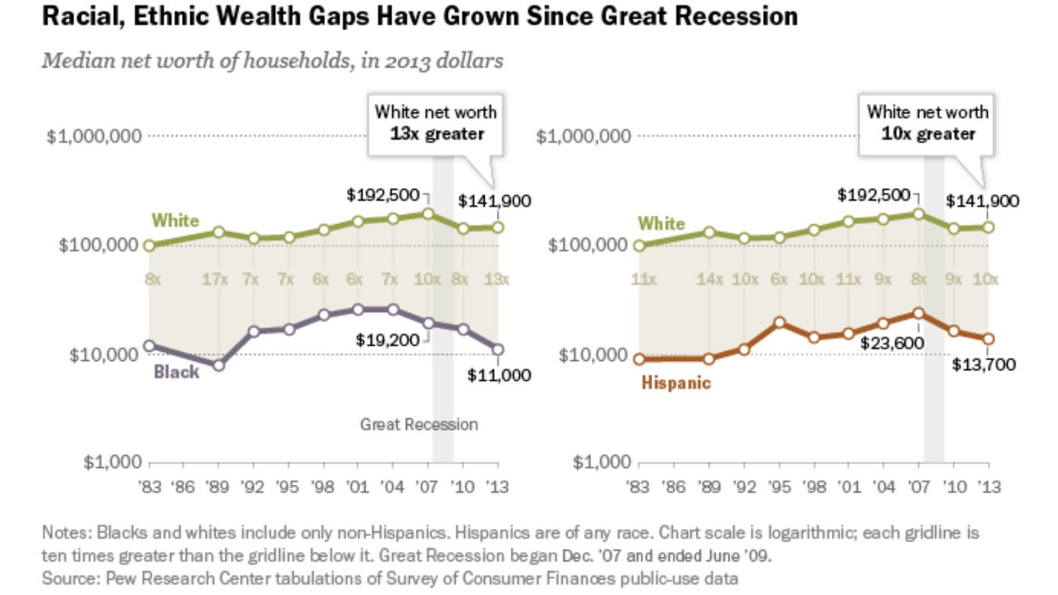
As you can see, the median net worth of white Americans is 13 times greater than that of Black Americans. Now let’s look at the unemployment data for African Americans vs. White Americans with statistics compiled from December 2014 to November 2015.
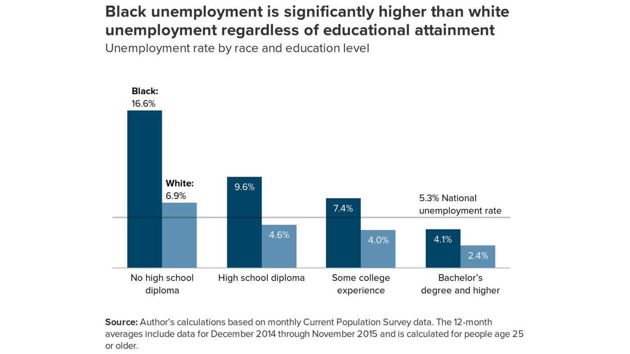
Currently the unemployment rate of African Americans is being celebrated by some as the lowest in the history of the U.S.; and to be sure, there is definite improvement. However, the point should be made that should there be an economic downturn for some reason, guess who suffers first and most?
HOUSING MARKET
- Segregation makes it unlikely that poor blacks will be able to escape poverty. For instance, 72 percent of black Americans born into the lowest economic quartile of neighborhoods reside in poor areas as adults, compared with only 40 percent of whites.
- Many studies have detailed the obstacles that minorities face from government agencies, real estate agents, money lenders, and white residents that continue to limit their housing options.
- In one study of lending practices done by the Kentucky Human Rights Commission, black and white testers with equal characteristics requested conventional mortgages for the same housing from ten of the top lending institutions in Louisville, and while there were cases in which discrimination was apparent (blacks having trouble getting appointments, etc.), in the eighty-five visits made to inquire about loans, none of the black testers (with one exception) knew they were being discriminated against, though all of them were. Blacks were given less information, less encouragement to return and apply for the loan, fewer helpful hints as to how to successfully obtain a loan, and differential treatment in prequalifying— sometimes being told they would not qualify when whites of the same profile were told they would.
- The racial practices of banks did not proceed in a color-blind fashion; as black neighborhoods were actively targeted for higher-interest loans. For instance, Wells Fargo recently settled a lawsuit with the NAACP for $ 175 million. The suit alleged that customers were steered toward higher-interest subprime loans— called “ghetto loans” for “mud people” within the organization. Although Wells Fargo has been a high-profile fall guy for this racist practice, the evidence suggests that banks routinely engage in discriminatory lending.
(Bonilla-Silva, Eduardo. Racism without Racists: Color-Blind Racism and the Persistence of Racial Inequality in America (Kindle Locations 926-927). Rowman& Littlefield Publishers. Kindle Edition.)
NOTE: We have forgotten the first martyr of the American revolution was a free African American.
Conclusion
In our research, an African American lady was interviewed and asked her this question; “How does racial discrimination make you feel?” Her response is the real picture of the problem, “Well, you just get used to it.”
One afternoon, one of our white staff members was running errands with a young African American male and they stopped by a local shopping establishment. This young man was dressed in a suit and tie and look professional. As they walked through the store, the white staff member noticed that they were being followed by security. It was the only time he had ever been followed by security in any store. On later reflection, he realized that to his young African American friend that to him it was just a normal shopping experience and he was no longer even angry from that less than subtle form of discrimination.
Racism in America today has become refined and acceptable. The dominant economic culture in America is still white and those who suffer poverty in the largest numbers are black. Who then holds the power to change things significantly for the better to lift our African American brothers and sisters out of economic suffering?
While a large section of America would profess to be “color blind” the data we’ve already presented, and there is much more, suggests otherwise. We have actually heard this term used in talks about race and have come to believe it has another meaning. Perhaps the “blindness” has deteriorated and we can no longer even see the pain of our black brothers and sisters. Maybe we’re just “blind.”
“A new command I give you: Love one another. As I have loved you, so you must love one another.” John 13:34 - NIV

Professor Bonilla-Silva writes: “Whites’ collective denial about the true nature of race relations may help them feel good, but it is also one of the greatest obstacles to doing the right thing. In racial matters as in therapy, the admission of denial is the preamble for the beginning of recovery.”(Bonilla-Silva, Eduardo. Racism without Racists: Color-Blind Racism and the Persistence of Racial Inequality in America (p. 307). Rowman& Littlefield Publishers. Kindle Edition.)

“If there is no struggle, there is no progress. Those who profess to favor freedom, and yet deprecate agitation, are men who want crops without plowing up the ground. They want rain without thunder and lightning. They want the ocean without the awful roar of its many waters. This struggle may be a moral one, or it may be a physical one, or it may be both moral and physical, but it must be a struggle. Power concedes nothing without a demand. It never did and it never will.” – Fredrick Douglas
(Douglass, F. (1855). My Bondage and My Freedom. London, England: Partridge and Oakey).

A definition of racism
1 : a belief that race is the primary determinant of human traits and capacities and that racial differences produce an inherent superiority of a particular race.
https://www.merriam-webster.com/dictionary/racism

A definition of poverty
1 a :the state of one who lacks a usual or socially acceptable amount of money or material possessions.
https://www.merriam-webster.com/dictionary/poverty

Solutions
There really is no easy answer. While laws are a good start, there really needs to be a change of heart. The ideas presented as solutions are a place to begin.
- Accurate history needs to be taught in schools from elementary through High School.
  - This should include the history of the African Continent and the negative impact that colonialism brought. Africa had a glorious history of advancement and nobility that has largely been forgotten.
  - American History integrated history to show African Americans as more than mere slaves but as vital members of our nation.
- Conversations with a purpose to understand each other’s culture are critical.
  - The only time there seems to be an impetus to have these conversations are when there is some race related crisis. That is not the time to have these discussions. Unfortunately, that is the only time anybody wants to talk.
  - This might be uncomfortable. But must be done with an open heart and open mind. Once in separate conversations with older gentlemen, one white and one black, about what life was like when schools integrated they both had very different impressions about how it went. They both were telling the truth.
- White Americans need to read and study more about black culture.
- White Americans need to look at current events through black eyes.
  - Example: Why did most white Americans assume that Trayvon Martin was guilty and thus worthy of being shot. Consider it from this angle: What if Trayvon had used the Stand Your Ground Law to support him shooting killing George Zimmerman who was following him. Being a 17 year old boy being followed by a grown up would create fear and could have caused him to want to defend himself. How would white America report the killing of George Zimmerman?
- State and federal legislatures need to pass bills apologizing for the enslavement of Africans and for years of discrimination.
- States should pass a law that triggers an action committee (Social workers, government officials, law enforcement and business representatives) to be formed to investigate and suggest changes if any local jail or prison has a disproportionate number of minorities in detention.
  - Note we acknowledge the numbers will never be exactly right on but jails/prisons should be a microcosm of the local population when it comes to race. How much off a community is off would need to be negotiated.
  - Note this is not to be an affirmative action type program for jail. Instead it should trigger an investigation into why that is happening at any given time.
  - Numbers should be examined monthly.

References
- https://www.history.com/topics/black-history/slavery
- https://www.colorado.edu/ibs/es/alston/econ4524/lectures/slavery.pdf
- Phillips,Ulrich B."Approximate Prices of Prime Male Field Hands in Hundreds of Dollars per Head. - . ," in“Life and Labor in the Old South, Boston,”Little, Brown, 1941, p. 177.
- Dawkins, Yanique,“8 Ways Slavery Affected Black Families and Still Has an Impact Today” October 13, 2014.
- Bonilla-Silva, Eduardo. Racism without Racists: Color-Blind Racism and the Persistence of Racial Inequality in America (p. 3). Rowman& Littlefield Publishers. Kindle Edition.
- Chavis, Ben.“Challenging Economic Racism in America,”May 15, 2015, Philadelphia Tribune
- Line graph - Pew Research Center on Racial and Ethnic Wealth Gaps Since the Great Recession, 2007-2009. (published in 2013).
- Bar graph - Pew Research Center on Black Unemployment, 2007-2009. published in 2013.
- Douglass, F. (1855). My Bondage and My Freedom. London, England: Partridge and Oakey.
- (The Bible, New American Standard Version, John 13:34)
- https://www.merriam-webster.com/dictionary

Contributors
Lead Author: Jack Murr
Daniel Blankenship
Phyllis Lewelling
Charolette Sanders
Rich Schaus
Sandy Coe
Jim Essert
Mark Bowser

