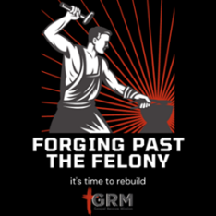
Forging Past the Felony
Week 1
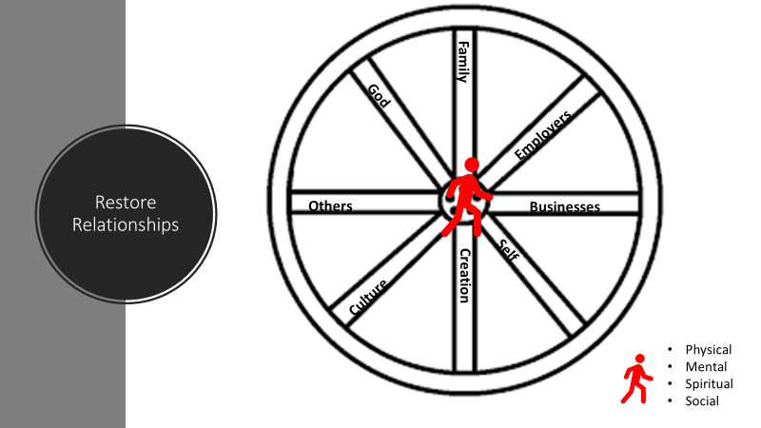

https://youtu.be/5JCm5FY-dEY
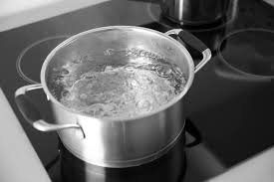
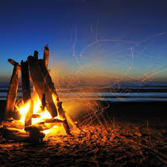

Boiling Water 212 Degrees Start Fire 451 degrees

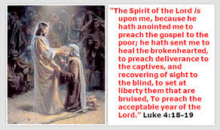
Homework Questions:
- What have you given the world?
- Who do I aspire to be?
- What am I good at?
- What do I love to do?
- What does the world need?
- How do I make moments magical?
- How can I use this course to launch my dreams?
- Why must I use this information?
- When will I use this information?
- What is one small domino you can push today?
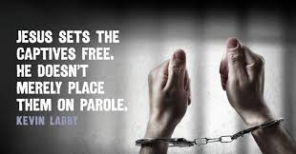

Rank these Virtues (1 the most important to you, 24 least important) https://www.viacharacter.org/
Appreciation | Humility | Persistence
Bravery | Humor | Perspective
Creativity | Integrity | Prudence
Curiosity | Kindness | Self-Regulation
Fairness | Leadership | Social Intelligence
Forgiveness | Love of Learning | Spirituality
Gratitude | Be Loved | Teamwork
Hope | Open mindedness | Zest

The Spirit of the Sovereign Lord is on me,
because the Lord has anointed me
to proclaim good news to the poor.
He has sent me to bind up the brokenhearted,
to proclaim freedom for the captives
and release from darkness for the prisoners
Isaiah 61:1

