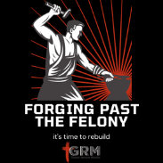
Forging Past the Felony
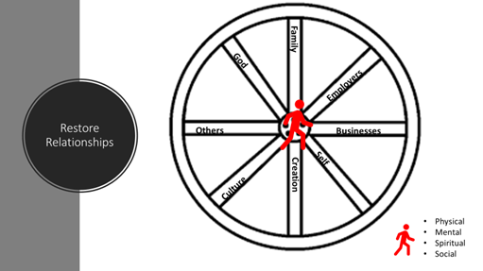
Week 2
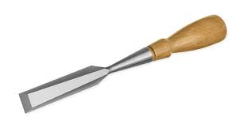

https://youtu.be/79Dzr86JkKY
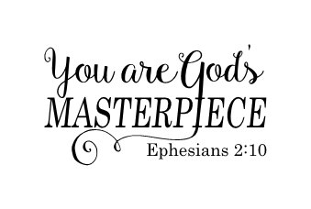
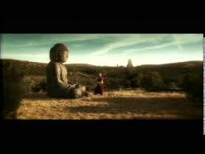

Key Points:
- You were created/ designed by God in perfection. You are God’s masterpiece.
- Overtime your real beauty has been covered in clay.
- You have made mistakes but you are not a mistake.
- It is OUR responsibility to go make those mistakes right.
- Blame is not helpful. Find your 1% in every situation.
- We all have baggage and Jesus wants to work with you to clean up the mess.

Homework Questions:
- What have I received from the world?
- What are my triggers? (To be angry, happy, to relapse, to be sad) List at least 10 (Trigger/Response)
- What are my current obstacles that I see between here and my dreams?
- How can I use this information to launch my dreams?
- Why must I use this information?
- When will I use this information?

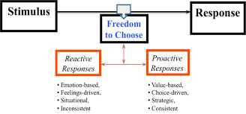

BASE WORK

EAT
MOVE
SLEEP
BREATHE

