Forging Past the Felony
Week 3
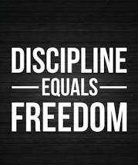
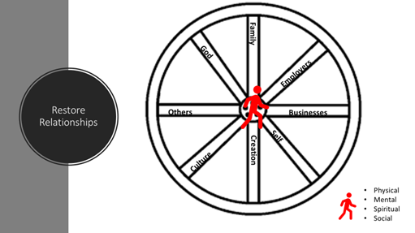

https://youtu.be/pxBQLFLei70

Key Points:
- In order to make our wheel go around we need to work on all of the spokes
- In order to accomplish our dreams we need a master plan
- A dream that we have not taken the time to write down is a fantasy.
- Will power leaks all day. We need to create personal algorithms so that we can conserve will power.
- Make your story real in your head first.

Homework Questions:
- What have I taken from the world?
- Who have I hurt?
- If I woke up tomorrow and my life was ideal. What would that look like? Fill out Goal Setting Sheet or create a master plan
- List 15 algorithms for your day.
- How can I use this information to launch my dreams?
- Why must I use this information?
- When will I use this information?

BASE WORK

EAT
MOVE
SLEEP
BREATHE

