Forging Past the Felony
Week 4

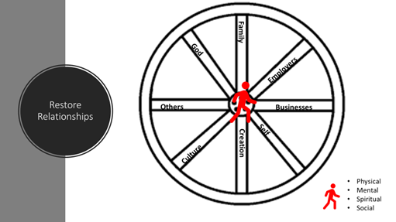
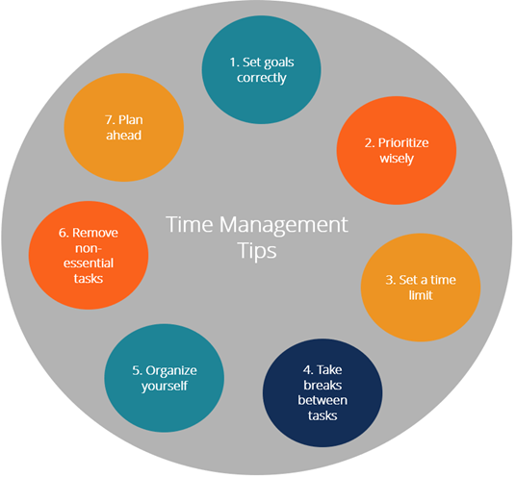

https://youtu.be/bQL37ZvTrHg

Key Points:
- Self-Evaluation and self-examinations
- If we don’t manage our time, it will manage us
- Personal growth is a lifestyle
- Did my life today take me closer or further from the sweet spot

Homework Questions:
- Conduct 3 self-evaluations this week
- Track how you spent your time this week then put each task you do today into one of the quadrants below.
- Evaluate how you could have done better
- How can I use this information to launch my dreams?
- Why must I use this information?
- When will I use this information?
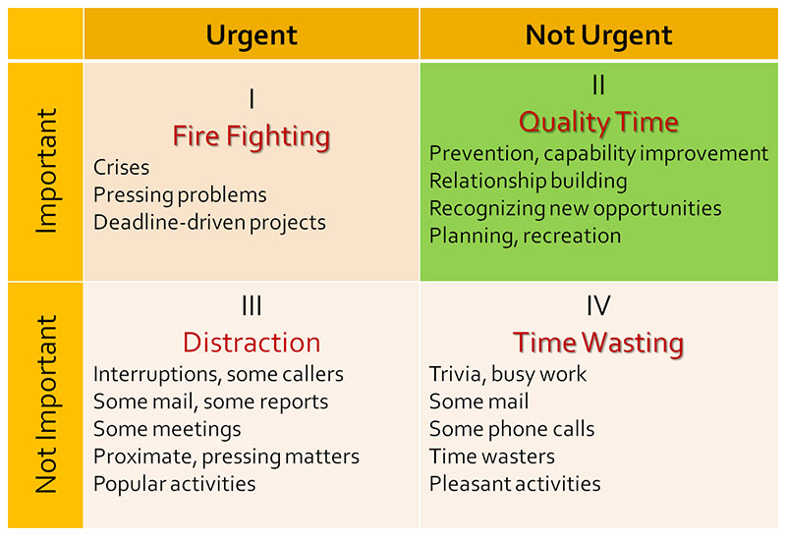

BASE WORK

EAT
MOVE
SLEEP
BREATHE

